**Project Details**

Project name: Learner Academy (Project 2)

Developer details: Nikhil Sapkal

**Sprint Details**

Sprint planning: Total 2 Sprint = 1st sprint (2 Week duration) + 2nd sprint (1 Week duration)

**\*1st Sprint (2 Week duration) details are as follows:**

* Max Story Point= 8 days
* Features “Login “, “Class list” and “Students List” takes 8 days to develop

**User Stories:**

US_001:

As a customer I want to have the credentials So that i can enter into the portal

US_002:

As a customer I want to have the option to add, edit and delete Class So that i can

view class detail

US_003:

As a customer I want to have the option to add, edit and delete Students So that i can

view student detail

**\*2st Sprint (1 Week duration) details are as follows:**

- Max Story Point= 5 days

- Features “Subject list”, “Teacher list” and “logout” takes 5 days to develop

**User Stories:**

US_004:

As a customer I want to have the option to add, edit and delete Subject So that i can

view subject detail

US_005:

As a customer I want to have the option to add, edit and delete Teacher So that i can

view teacher detail

US_006:

As a customer I want to have logout option So that i can logout from portal

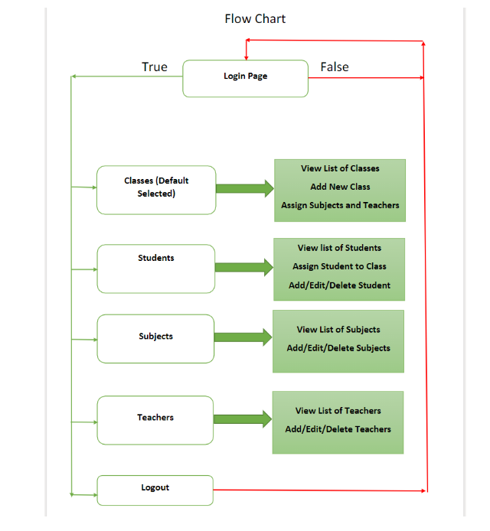 **Algorithm and flowchart**

**Algorithm:**

A. Login the page

B. Choose one of below link

1. Classes (Default one)

2. Student

3. Subjects

4. Teacher

5. Logout

C. View and edit the list of respective above option

D. Print user defined output

E. Go to step B

**Core Concept Used**

1)**Collection** to store list of class, student, subjects and teacher details etc

2)**JSP** and **HTML** code used for developing project

3)Project is **Loosely coupled** (i.e POJO, DAO, DB Connection Classes are kept independent)

4)**Exception Handling** to handle exception

**Git Hub repository Link**

<https://github.com/sapkani/Learner-Academy.git>

**Conclusion**

Learner academy portal to keep track of its classes, subjects, students, and teachers is achieved using Java programming concept